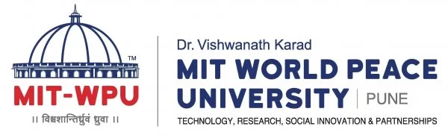

Department of Polytechnic and Skill Development

Parent/Guradian consent form for Internship Training

To all concerned, Date: 13/5/2025

I_______________________________________________________grant permission for
my child\ward___________________________________student of Department of Polytechnic & Skill Development of the Dr.VK MIT World Peace University, Pune, to undergo internship training in order to acquire work experience related to the academic training.
By signing this document, it is understood that my child/Ward,

a) Has been properly oriented with all the rules & regulations in the conduct of internship training & that there may be additional rules, regulations that may be given from time to time. It is further understood that he/she most comply with the aforesaid rules, regulations & instructions otherwise, he/she will be excluded from further participation.

b) Shall abide by all the company rules & regulations & shall comply with those imposed for the program, otherwise, he/ she will be excluded from the further participation. Also He/ she will not be getting credits of internship and also he/ she has to repeat the Internship.

c)Shall exercise care & diligence in any task assigned to him/her,

d)Shall be made answerable for any and all liabilities for damages for properly or injury to third person, which may be occasioned by his/her intentional or negligent act while in the course of his/her training.

Student Name & Signature
Mobile No.

Parent Name & Signature
Mobile No.

